IPv4 Issues

The need for IPv6

IPv4 is running out of addresses, that is why u need to learn about IPv6

**IPv6 is designed to be the successor to IPv4**  
 It has larger 128-bit address space, providing 340 undecillion possible addresses

When IETF began its development of successor to the IPv4, it used this opportunity to fix the limitations of IPv4 and include enhancements. Example: internet control message protocol version 6 (ICMPv6)

IPv4 and IPv6 coexistence

**There is no specific date to move to IPv6**  
 Both IPv4 and IPv6 will coexist in the near future and the transition will take several years

**The IETF has created various protocols and tools to help network administrators migrade their networks to IPv6**

**The migration techniques are:**

DUAL STACK

**Allows IPv4 and IPv6 to coexist on the same network segment**

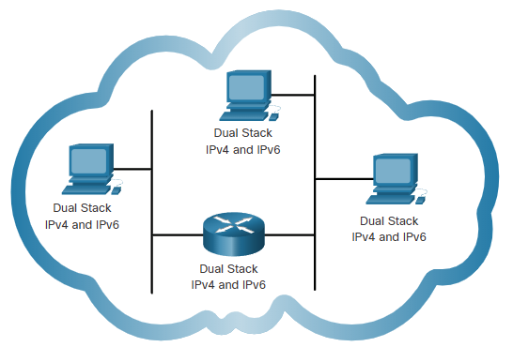

TUNNELING

Method of **transporting an IPv6 packet over an IPv4 network**

IPv6 packet is encapsulated inside an IPv4 packet

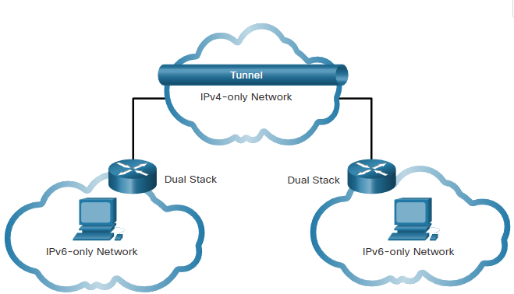

TRANSLATION

Network address translation 64 (NAT64) allows IPv6-enabled devices to communicate with IPv4-enabled devices using a **translation technique** similar to NAT for IPv4

